**DAILY ONLINE ACTIVITIES SUMMARY**

|  |  |  |  |  |  |  |  |
| --- | --- | --- | --- | --- | --- | --- | --- |
| **Date:** | **11-6-2020** | | | | **Name:** | **K Manasa** | |
| **Sem & Sec** | **8th sem A sec** | | | | **USN:** | **4al16cs043** | |
| **Online Test Summary** | | | | | | | |
| **Subject** | | **sms** | | | | | |
| **Max. Marks** | | **60** | | **Score** | | **54** | |
| **Certification Course Summary** | | | | | | | |
| **Course** | **Introduction to cyber security** | | | | | | |
| **Certificate Provider** | | | **Great learning academy** | **Duration** | | | **5.5hr** |
| **Coding Challenges** | | | | | | | |
| **Problem Statement:**  **1.** **C Program to find the length of a String without**  **using any standard library function** | | | | | | | |
| **Status:completed** | | | | | | | |
| **Uploaded the report in Github** | | | | **yes** | | | |
| **If yes Repository name** | | | | **Manasa** | | | |
| **Uploaded the report in slack** | | | | **yes** | | | |

**Online test**

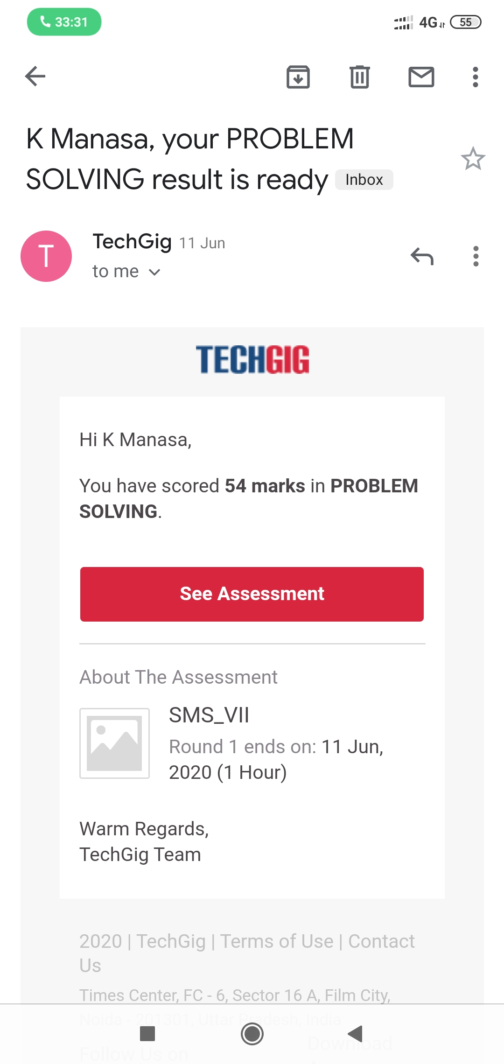

**Certification course**

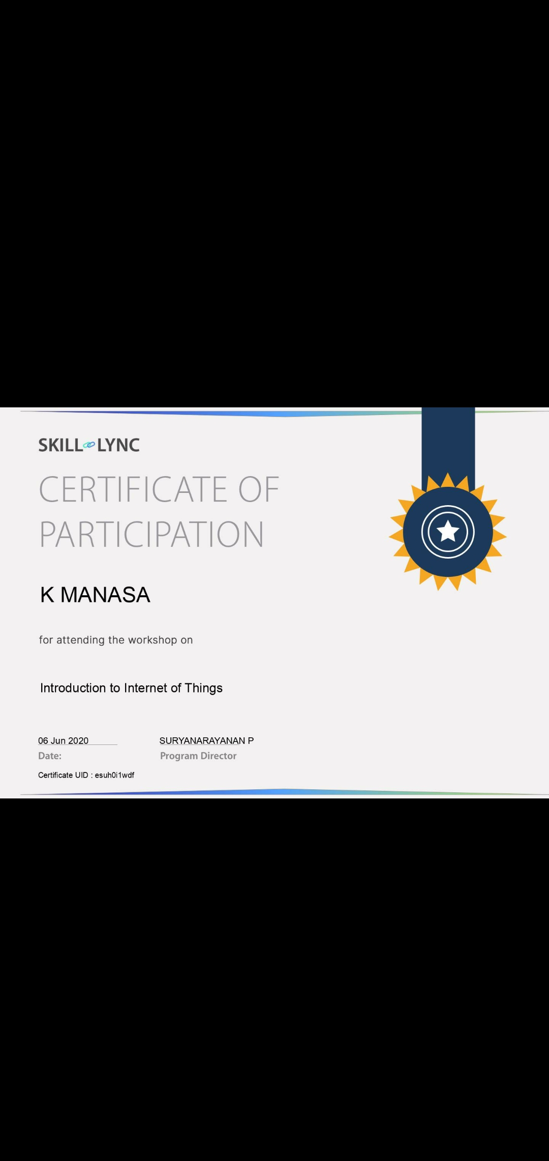

**Coding**

**Program 1**

**/* C Program to find the length of a String without**

**using any standard library function**

**\*/**

**#include <stdio.h>**

**int main()**

**{**

**char str[100],i;**

**printf("Enter a string: \n");**

**scanf("%s",str);**

**for(i=0; str[i]!='\0'; ++i);**

**printf("\nLength of input string: %d",i);**

**return 0;**

**}**